**What is the servlet?**

Servlet is the technology that is used to create the dynamic web pages.

Pre-requisites

Apache tomcat server.

Eclipse for web

JDK install

Note-

1. Download the tomcat and install it or
2. Download the tomcat and keep in into C drive directly.

**Difference between web server and application server.**

|  |  |
| --- | --- |
| Web Server | Application Server |
| Web server contain the web or servlet container | Application server contain web and EJB container. |
| It contain JSP, Servlet, HTML file | It contain the JSP, Servlet, HTML, EJB and JMS |
| Apache tomcat | JBoss, Weblogic, webSphere |
| It is the light weight components. | It is the heavy weight components |

**Why is Server needed?**

If you don’t use any server then whole project or web pages is stored into local hard disk. If someone wants to access the web site or project globally then how can access it? So every time he or she needs to use your laptop.

So to overcome this issue, server comes into the picture.

Download and install the tomcat server.

1. Use of bin folder->to start and stop the server
2. Startup.bat file is used to start the server.

**Life cycle of Servlet**

The web or servlet container maintains the life cycle of a servlet instance. Let's see the life cycle of the servlet:

1. Servlet class is loaded.
2. Servlet instance is created.
3. Init method is invoked.
4. Service method is invoked.
5. Destroy method is invoked.

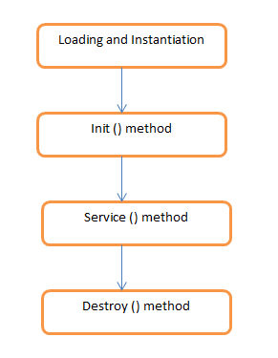

Fig- Servlet Life Cycle

As displayed in the above diagram, there are mainly three states of a servlet such as init, service and destroy.

1. Servlet class is loaded.

The class loader is responsible to load the servlet class. The servlet class is loaded when the first request for the servlet is received by the web container.

1. Servlet instance is created.

The web container creates the instance of a servlet after loading the servlet class. The servlet instance is created only once in the servlet life cycle.

1. Init method is invoked.

The web container calls the init method only once after creating the servlet instance. The init method is used to initialize the servlet. It is the life cycle method of the javax.servlet.Servlet interface. Syntax of the init method is given below:

public void init(ServletConfig config) throws ServletException

1. Service method is invoked.

The web container calls the service method each time when request for the servlet is received. If servlet is not initialized, it follows the first three steps as described above then calls the service method. If servlet is initialized, it calls the service method. Notice that servlet is initialized only once. The syntax of the service method of the Servlet interface is given below:

public void service(ServletRequest request, ServletResponse response)

throws ServletException, IOException

1. Destroy method is invoked.

The web container calls the destroy method before removing the servlet instance from the service. It gives the servlet an opportunity to clean up any resource for example memory, thread etc. The syntax of the destroy method of the Servlet interface is given below:

public void destroy()

**How to create the first servlet program.**

Open the Eclipse

Click on File icon-> New-> other-> Search Web

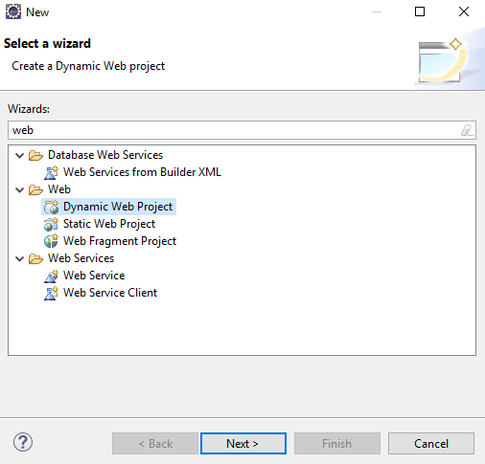

Select the Dynamic Web Project

After new window will be displayed as below

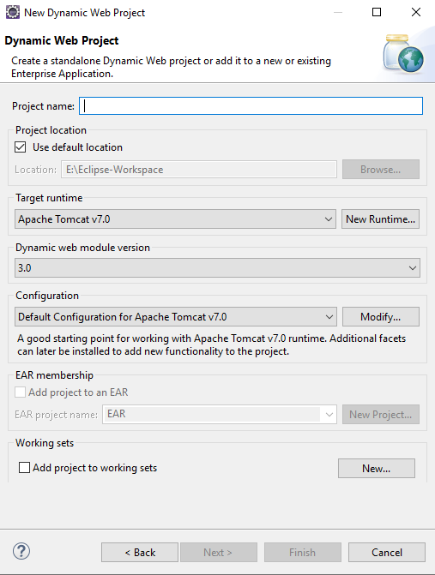

Write the Project name as FirstServlet and then click on Next button

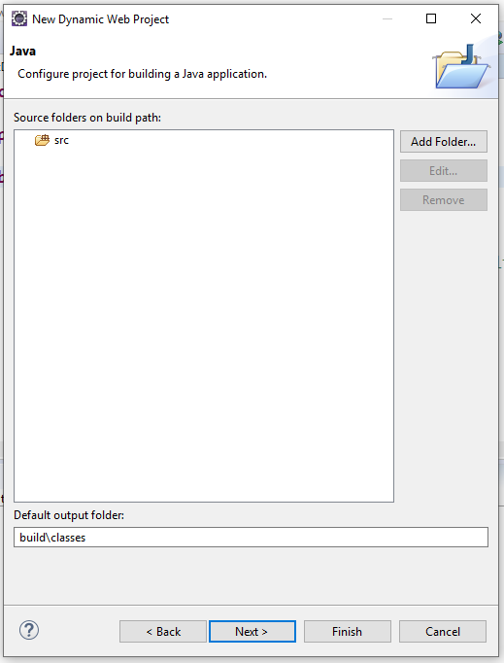

Click on Next button

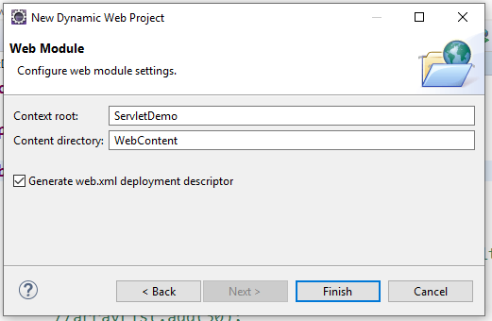

Select the checkbox as clickable then click on finish button.

Right click on Project->New->Select Servlet->

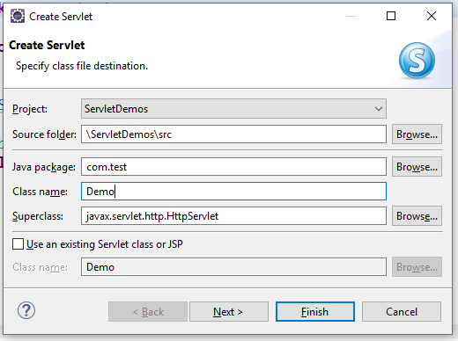

Enter the package and class name then Click on Next Button

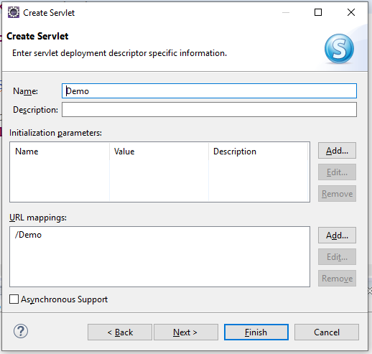

Click on Next Button

Uncheck the all and check only service option and then click on finish.

**Note**- Add Servlet-API jar file.

Project->Right Click on it->Build Path->Configure Build Path->click on Add External Jar file-Go to path where you downloaded the servlet api jar file select it. then click on Apply and close button.

Add Server to run the web application.

Go to window->Show view->other->Search Server-> select it.



Click this link to create the new server.

**How to add New Server**

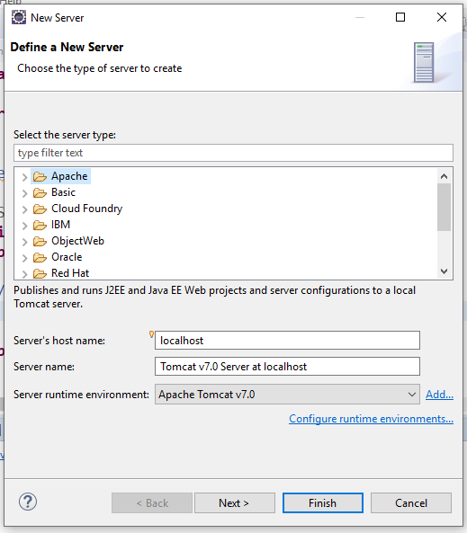

Select Tomcat v7.0 Server from Apache list and click on Next button.

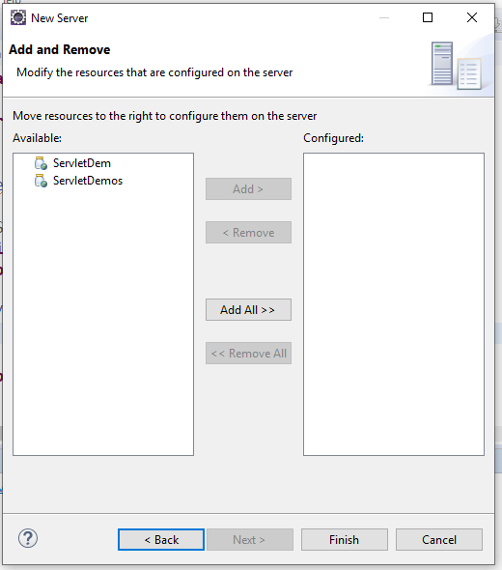

Select the project from the list and click on Add button then will see Project into configured

Then click on finish button.

**How to run the Web Project.**

Right click on Project-> Run as-> Run on Server.

See the screen

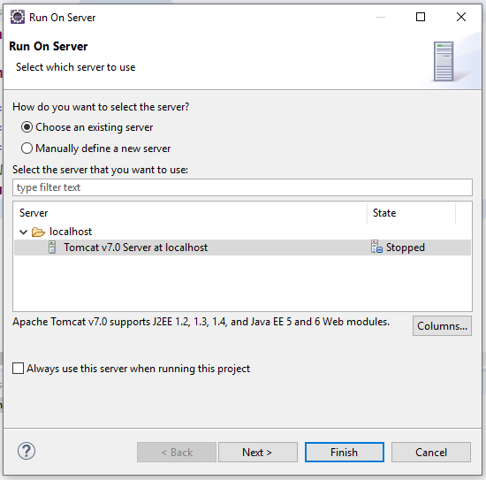

Click on Next Button-> Finish button.

Then will displayed the message on console.

Feb 03, 2021 11:47:44 AM org.apache.catalina.startup.Catalina start

INFO: Server startup in 11081 ms

It means server is started.

**Project Structure**

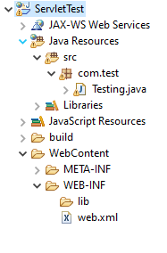

**Testing.Java**

**package** com.test;

**import** java.io.IOException;

**import** java.io.PrintWriter;

**import** javax.servlet.ServletException;

**import** javax.servlet.annotation.WebServlet;

**import** javax.servlet.http.HttpServlet;

**import** javax.servlet.http.HttpServletRequest;

**import** javax.servlet.http.HttpServletResponse;

/**

* Servlet implementation class Testing

*/

**public** **class** Testing **extends** HttpServlet {

**private** **static** **final** **long** ***serialVersionUID*** = 1L;

**public** Testing() {

System.***out***.println("in testing constructor");

}

@Override

**public** **void** destroy() {

System.***out***.println("in destroy method");

}

@Override

**public** **void** init() {

System.***out***.println("in init method");

}

**protected** **void** service(HttpServletRequest request, HttpServletResponse response)

**throws** ServletException, IOException {

System.***out***.println("in service method");

PrintWriter out=response.getWriter();

out.print("<h1>This is the first servlet......</h1>");

}

}

**Web.xml**

<?xml version=*"1.0"* encoding=*"UTF-8"*?>

<web-app xmlns:xsi=*"http://www.w3.org/2001/XMLSchema-instance"*

xmlns=*"http://java.sun.com/xml/ns/javaee"*

xsi:schemaLocation=*"http://java.sun.com/xml/ns/javaee http://java.sun.com/xml/ns/javaee/web-app_3_0.xsd"*

id=*"WebApp_ID"* version=*"3.0"*>

<display-name>ServletTest</display-name>

<servlet>

<servlet-name>test</servlet-name>

<servlet-class>com.test.Testing</servlet-class>

</servlet>

<servlet-mapping>

<servlet-name>test</servlet-name>

<url-pattern>/welcome</url-pattern>

</servlet-mapping>

</web-app>

URL- <http://localhost:8080/ServletTest/welcome>

**Output-**

This is the first servlet......